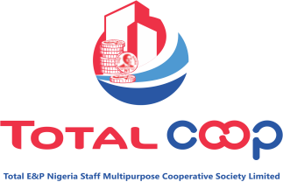

PROJECT NEEDS ASSESSMENT (CLEARING OF TAG COOP LAND)

|  |  |
| --- | --- |
| **PROJECT NAME** | Clearing and Catting away of debris at Total coop TAG land located in trans Amadi Port |
| **REQUESTING DEPT.** | Business Development Department |
| **REQUEST STATUS** | Pending |
|  | |
| **PROJECT OBJECTIVE** | To enable cooperative tidy up the environment in preparation for construction work. |
|  | |
| **JUSTIFICATION FOR PROJECT REQUEST** | 1. The land is overgrown by weed   2). Coop need to show more presences against community encroachment.  3). This will enable the security patrol team to move around the perimeter fence for proper monitoring and control.  4),The Trans Amadi Residence Association has complained of the overgrown weeds housing reptiles and other dangerous scorpions. |
|  | |
| **PROPOSED CLEARING SCOPE DESCRIPTION** | **The Clearing of the land entails**   1. The plot of land is 50 standard plots if sub divided.   2.) The use of excavator or bulldozer to clear the entire land  3.) The use of tipper to remove the cleared debris  4.) Move the debris to an approved refused dump site for disposal. |
|  | |
| **CONSTRAINTS** |  |
|  | |
| **PROCUREMENT ROUTE** | Procurement strategy in line with COOP procurement process |
|  | |